Module 2
In this module there are 4 assignments.
Assignment 1:
Create a Java program that calculates and displays the cost of purchasing a specified number of items, each priced at a certain amount, with a given tax rate and discount. The program should perform calculations using various operators in Java, without using objects and classes and without user input. The program should display the total cost, including tax and discount.
Your program should perform the following tasks:
- Define the following variables with predefined values:
itemPrice: the price of each item (e.g., $10.00).
numberOfItems: the number of items to be purchased (e.g., 5).
taxRate: the tax rate as a percentage (e.g., 8%). discountPercentage: the discount rate as a percentage (e.g., 10%).
- Calculate the following:
subtotal: the total cost before tax and discount. taxAmount: the amount of tax based on the tax rate.
discountAmount: the amount of discount based on the discount rate. totalCost: the final total cost, including tax and discount.
Display the calculated subtotal, taxAmount, discountAmount, and totalCost in the output.

Solution:
import java.util.Scanner;

public class Cost {
public static void main(String[] args) {
Scanner sc = new Scanner(System.in);
double itemPrice = 10.00;
int numberOfItems = 5;
double taxRate = 8.0;
double discountPercentage = 10.0;

double subtotal = itemPrice * numberOfItems;
double discountAmount = subtotal * discountPercentage / 100.0;
double taxAmount = (subtotal - discountAmount) * taxRate / 100.0;
double totalCost = subtotal + taxAmount - discountAmount;

System.out.println("Total: $" + subtotal + "\nDiscount: $" + discountAmount + "\nTax Amount: $" + taxAmount
+ "\nGrand Total: $" + totalCost);
}
}

Output:
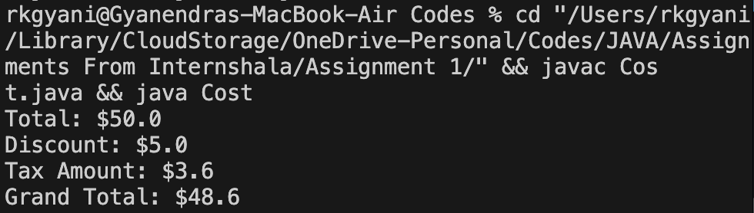

Assignment 2:
Create a Java program that simulates a simple dice game without using objects and classes and without user input. The program should allow two players to take turns rolling a standard six-sided die (with numbers 1 to 6). Each player rolls the die once per turn, and the program keeps track of the total score for each player. The game should continue until one of the players accumulates a predefined winning score.
Your program should perform the following tasks:
- Define a predefined winning score (e.g.50 points).
- 2.Simulate a two-player dice game where each player takes turns rolling a six-sided die.
- Update and display the total score for each player after each turn.
- Continue the game until one of the players reaches or exceeds the winning score.
- Display the winner and their final scores.

Solution:
import java.util.*;
public class Dice_Game
{
public static void main(String[] args)
{
int ws=50;//winning score
int i,p1=0,p2=0;
for(i=1;;i++)
{
if(i%2!=0)
p1=p1+(int)(Math.random()*(6-1+1)+1);
else
p2=p2+(int)(Math.random()*(6-1+1)+1);
if(p1>50 || p2>50)
break;
}
if(p1>50)
System.out.printf("Player 1 wins with %d scores \n",p1);
else
System.out.printf("Player 2 wins with %d scores \n",p2);
}
}

Output:
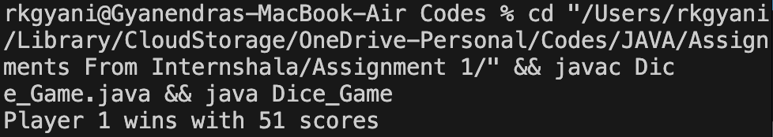

Assignment 3:
You are given a sentence as a string in Java. Your task is to reverse the order of the words in the sentence while preserving the order of the characters within each word.
For example, if the input sentence is: "Hello World Java"
Your program should produce the output: "Java World Hello"
Write a Java program that takes an input sentence, performs the word reversal, and prints the modified sentence.

Solution:
import java.util.*;
public class Reverse_String
{
public static void main(String[] args)
{
Scanner sc= new Scanner (System.in);
System.out.print("Enter the sentence: ");
String s=sc.nextLine();
String[] words=s.trim().split("\\s+");
int n= words.length;
String[] word= new String[n];
int d=n;
for(int i=0;i<n;i++)
{
word[--d]=words[i];
}
s=String.join(" ",word);
System.out.println(s);
System.out.println(n);
}
}

Output:
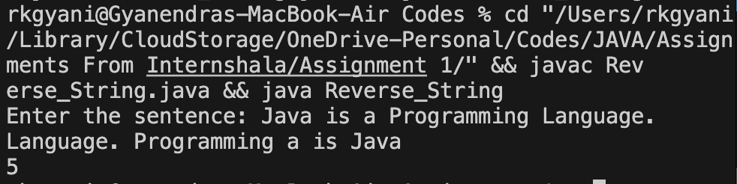

Assignment 4:
You are tasked with writing a Java program to analyze daily temperature data for a week. The program should take the following input:
The number of days in the week (e.g., 7 for a full week).
The daily high temperatures for each day.
Your program should calculate and display the following information:
The average daily temperature.
The highest daily temperature.
The lowest daily temperature.
The number of days with temperatures above 80 degrees Fahrenheit.
The number of days with temperatures below 60 degrees Fahrenheit.
Write a Java program that accomplishes this task.

Solution:
import java.util.*;
public class Temparature
{
public static void main(String[] args)
{
Scanner sc=new Scanner(System.in);
System.out.println("Enter no. of days: ");
int d=sc.nextInt();
int[] h= new int[d];
int[] l= new int[d];
double[] a= new double[d];
int i, ht=0, lt=0, n6=0, n8=0;
System.out.print("Enter daily highest temparature: ");
for(i=0;i<d;i++)
h[i]=sc.nextInt();
System.out.print("Enter daily lowest temparature: ");
for(i=0;i<d;i++)
l[i]=sc.nextInt();
ht=h[0]; lt=l[0];
for(i=0;i<d;i++)
{
a[i]=(h[i]+l[i]/2.0);
if(h[i]>ht)
ht=h[i];
if(l[i]<lt)
lt=l[i];
if(h[i]>60)
n6++;
if(h[i]>80)
n8++;
}
for(i=0;i<d;i++)
System.out.printf("Highest is: %d and Lowest is: %d Temprature of Day %d \nAverage Temprature is: %f \n",h[i],l[i],i,a[i]);
System.out.println("No. of Dyas with Temp. >80 Degrees Fahrenheit: "+n8);
System.out.println("No. of Dyas with Temp. >60 Degrees Fahrenheit: "+n6);
}
}

Output:
